DSA-2000 Document No. 00034

Analog Signal Path Design Document

Sander Weinreb, Kiran Shila, Jonas Flygare, James W. Lamb

Caltech

|  |  |  |  |  |  |  |  |  |  |  |  |  |
| --- | --- | --- | --- | --- | --- | --- | --- | --- | --- | --- | --- | --- |
| |  |  | | --- | --- | | Version: | 1 | | Version date: | 2023-10-23 | | Original date: | 2023-10-15 | | Controlled document: | No | | WBS Level 2: | ASP–Analog Signal Path | | Document type: | DES–Design Report  Design Report | |
|  |

Revision History

| **Ver.** | **Date** | **Sections Affected** | **Reasons / Remarks** | **Author(s)** |
| --- | --- | --- | --- | --- |
| 1 | 2023-10-23 | All | Original | Weinreb, Shila, Flygare, Lamb |

Table of Contents

1 Introduction 4

2 Requirements 4

3 Design overview 5

4 Design details 6

4.1 Feed 6

4.2 LNA 9

4.3 Post-LNA electronics 10

4.3.1 Front-end module 11

4.3.2 Optical link 12

4.3.2.1 Link gain 12

4.3.2.2 Linearity 13

4.3.2.3 Link noise 13

4.3.2.4 Dealing with tolerances 14

4.3.2.5 Laser safety 15

4.3.3 Back-end module 15

5 Monitor and control 15

6 Future work 15

6.1 Development 15

6.2 Production readiness 15

7 Interfaces 16

8 Conclusions 16

9 References 16

10 Appendix 17

10.1 Sideband phase decoherence 17

10.2 Linewidth decoherence 17

10.3 Delay drift 18

Abstract

The analog signal path (ASP) comprises everything from the feed up to the input to the radio camera digitizer. We document the state of the design of the ASP at the date of this revision. The overall architecture is described, and details of the component parts presented. They have a strong heritage so that risks are minimized, and considerable progress has been made toward meeting the challenges of DSA-2000. The feed and low-noise amplifier are well advanced, and development is now focused on the optical link, with good progress being made.

# Introduction

The analog signal path comprises all the components between the antenna reflector and the radio camera digitizer. These are:

* The antenna feed, dual polarization;
* Two low-noise amplifiers (LNA), one per polarization;
* A dual-polarization front-end module (FEM) that filters out radio-frequency interference (RFI) and allows adjustment of the levels for transmission;
* Two RF-over-fiber (RFoF) link to transmit the signals to the control building, one per polarization;
* A dual-polarization back-end module (BEM) that conditions the signals for the radio camera front-end digitizer.

Physically, the optical transmit and receive components are incorporated in the FEM and BEM respectively, but they need to be considered along with the fiber transmission infrastructure as single system. Accordingly, we allocate a separate subsection to discussion of the optical link details.

The scale of the DSA-2000 does not allow for high-risk development, so the system described here is based on elements that have been designed and assessed in the field by members of the team and have been matured to meet the DSA-2000 requirements. The primary extension is to achieve the target of an observing band of 0.7–2.0 GHz. In addition, the fiber lengths are an order of magnitude longer than for current OVRO instruments. Improvements in system noise and efficiency have also been made, and methods of mitigating the effects of radio frequency interference (RFI) are being evaluated.

Several stages are planned to take the designs through to construction, including integration testing in the lab and on the test array; reliability testing; and finalizing designs for production. These are laid out in detail in a separate work execution plan.

We report on the status of the overall design and status of development in the following sections. Following that, we outline work needed to achieve the level of performance, reliability, and operational readiness for the final construction phase.

# Requirements

Specifications are derived from the science requirements on sensitivity. From Thompson et al. [1] the rms noise in a single baseline measurement for a single polarization expressed as an equivalent flux is

|  |  |
| --- | --- |
| $$S{}_{min}=\frac{2kT{}_{S}}{η_{q}A{}_{eff}\sqrt{N_{a}\left(N_{a}-1\right)}\sqrt{Bτ}} ,$$ | (1) |

where:

$k$: Boltzmann constant

$T_{S}$: system temperature

$N_{a}$: number of (identical) antennas

$A_{eff}$: effective antenna collecting area

$η_{q}$: quantization efficiency

$B$: bandwidth

$τ$: integration time

For a dual-polarization system this can be rearranged to give a relationship between the system noise temperature and aperture efficiency, $η_{a}$, and dish diameter, $D_{a}$, for given requirements:

|  |  |
| --- | --- |
| $$\frac{T_{S}}{η_{a}}≤S{}_{min}\frac{π}{8k} N{}_{a}{D_{a}}^{2}\sqrt{2Bτ} .$$ | (2) |

The quantization efficiency is assumed to be ~ 100%. The observing band is 0.7–2.0 GHz, but up to 35% bandwidth loss is acceptable. Using the science requirement for a sensitivity of 1 μJy in 1 hour of integration around declination 0° (elevation 52°) we derive a requirement of

|  |  |
| --- | --- |
| $$\frac{T_{S}}{η_{a}}=35 K.$$ | (3) |

The division between noise and efficiency is restricted by the current technology to a range from about 22.8 K/65% to 24.5 K/70%.

# Design overview

Figure 1 lays out the architecture of the signal path. The feed captures the signal from the primary reflector and the integrated orthomode transducer (OMT) couples the two orthogonal linear polarizations to low noise amplifiers (LNA) operating at ambient temperature. Coaxial cables connect the LNAs to an enclosure on the antenna turning head where the signals are amplified, filtered and the amplitude adjusted to a suitable power level. The resulting signal modulates the current in a laser diode and the optical signal is transmitted on a single-mode fiber to the control building.

The optical fibers to the control building will be up to ~ 21 km long and will have a number of splices and connectors that need to be made precisely to minimize optical losses. In the control building the fibers are connected to the back-end modules (BEM) that have photodiodes to convert back to RF. These signals are then filtered, amplified, and set to the appropriate level for the radio camera front-end analog to digital converters (ADC).

A major challenge is dealing with radio frequency interference (RFI). Major sources of concern in this band are ground-based cell phone communications and aeronautical navigation and, in the near future, satellite cell phone service. The project will select a site that is as free from these interfering signals as possible, and work on other protection and mitigation will proceed, but there will always be some level of interference to deal with. The uncertainty and variability will require several measures in the signal path to minimize the effect and to deal dynamically with variable and evolving levels. As described below, these strategies include filtering, both fixed and variable, and gain control to adaptively optimize the system.



Figure 1. Schematic of the analog signal path showing the locations of the major components.

The total gain required between the feed input and the digitizer is about 76 dB. To allow for some variation in component values, unpredictable RFI, antenna dependent fiber losses, etc., more gain is built into the signal path, and step attenuators allow fine adjustment to achieve optimum performance in operation. A major part of the design development is the RFoF link.

# Design details

In the following sections, the design details and status of the elements of the signal chain are reported. The emphasis is on the work that has been done to extend existing designs to meet DSA-2000 requirements. Areas of particular concern are dealt with in some detail.

## Feed

To meet the requirements of DSA-2000, the feed, in combination with the 5-m diameter antenna paraboloidal reflector, needs to achieve high aperture efficiency, low noise, and low wide-angle sidelobes over a 0.7–2.0 GHz band. Several techniques are used to achieve this in a quad-ridge choke horn (QRCH) design with a low-loss dielectric lens [2]–[4]. The excitation point[1] for each polarization is essentially a probe across a circular ridged waveguide, with a short coaxial cline to the connector. Ridged waveguides have higher single-mode bandwidth than circular waveguides, a useful quality for the application. The two orthogonal ridged guides share the same cylindrical outer wall. From the excitation points, the ridges taper outward to reduce the field coupling to the metallic guide and transition into a free-space wave. At the aperture of the feed, separate measures are applied to control the low and high frequency behaviors. For the low frequencies, the tendency of part of the wave to diffract in the rearward direction is countered with a high-impedance corrugated choke structure, reducing the back lobe amplitude. For the mid to higher frequencies, a dielectric lens helps to control the phase and to broaden the illumination on the primary.

The antenna aperture efficiency, $η_{a}$, can be expressed as the product of several factors:

|  |  |
| --- | --- |
| $$η{}_{a}=η_{sp} η_{ill} η_{ph} η_{xp} η_{b}.$$ | (4) |

A practical feed size for weight and blockage is of order a wavelength, which allows little control of the pattern other than its width. Widening the beam improves the illumination efficiency, $η_{ill}$, but reduces the spillover efficiency, $η_{sp}$. The optimum width for aperture efficiency may not be the best for sensitivity if the spillover is at ambient temperature, compromising the system noise temperature, but the noise penalty is counteracted by a shield round the primary rim that directs spillover on to the cold sky [5].

The phase efficiency, $η_{ph}$, is maximized by ensuring the best-fit phase center is at the prime focus for all frequencies across the band. The residual error is quantified by $η_{ph}$. Cross-polar efficiency, $η_{xp}$, is maximized as much as possible following Ludwig’s third definition [6] as aperture cross polarization not only reduces on-axis efficiency, but also produces sidelobes in the intercardinal planes, compromising the goal of a circularly symmetric pattern. Blockage efficiency, $η_{b}$, reflects the reduction in aperture area due to the feed and its support structure.

Full electromagnetic finite-element analysis was required to optimize the feed performance [4]. The resulting design is shown in Figure 2, and the performance results are shown in Figure 3. Not included in the analysis to date is the radome that will be used to protect the lens and weatherize the feed.

Previous horn designs have been verified by pattern measurements in an anechoic chamber, giving high confidence in the simulations. Those measurements will also be done for the final DSA-2000 design before production and possibly on a small number of production items.

Brief summaries of the major components of the feed in Figure 2 and the motivation for each in the design are given below:

* **Choke-rings**
  + A deep “pan-like” structure;
  + Creates high-impedance surface, resulting in wider pattern with minimized side and back-lobes;
  + Effect is limited to octave band, predominantly the low frequencies.
* **Quad-ridge waveguide**
  + A circular metal ridge waveguide structure that provides bandwidth in a compact format with single-ended output, and linear dual-polarization;
  + Wide ridges for lower current density (i.e., reduced ohmic loss).
* **Dielectric load/lid/lens**
  + The dielectric load reduces aperture phase errors and widens the feed pattern for mid and high frequencies in the band;
  + Realized with low-loss thermoplastic, High Density Polyethylene (HDPE);
* **Radome**
  + Protects the lens from ultra-violet radiation, and the waveguide from weather;
  + Thermoformed microwave transparent material.

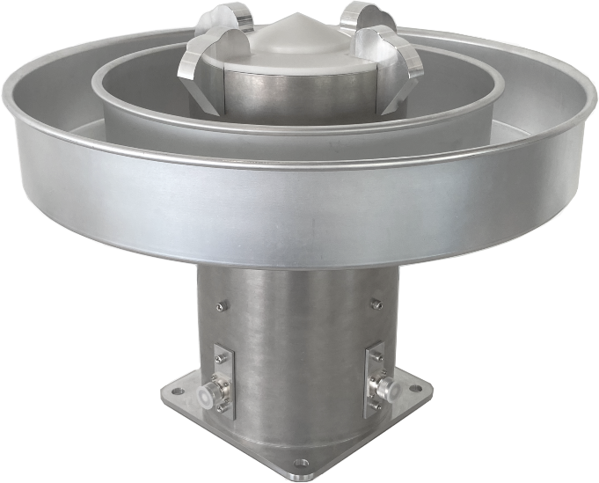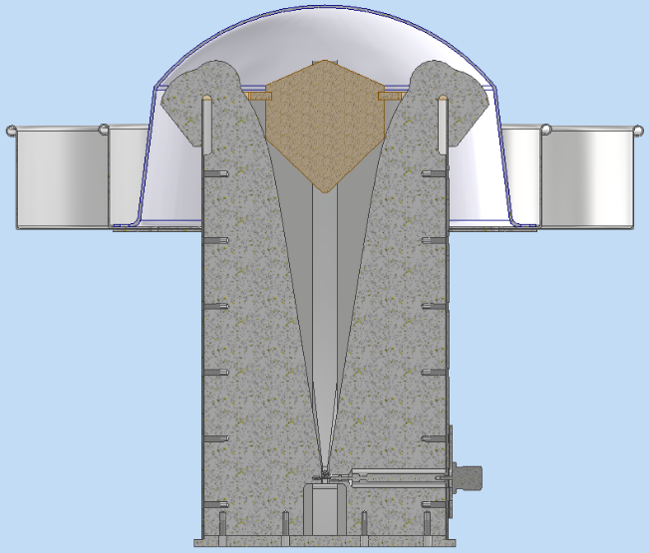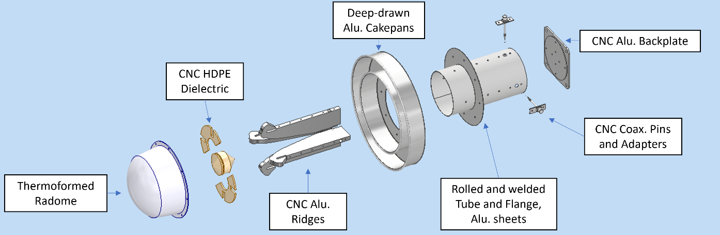

508 mm

Figure 2. *Left:* photo of prototype feed, and *Right:* cross-sectional drawing showing the principal components. The radome that will guard the lens against UV radiation and generally protect the feed from weather.

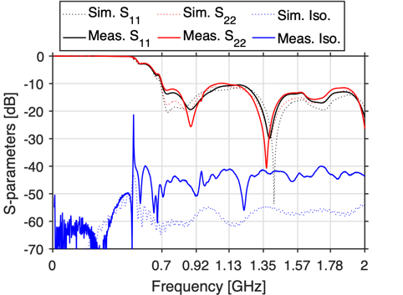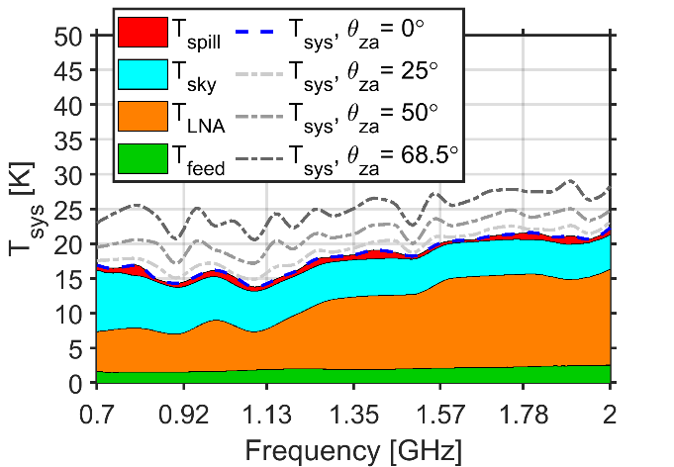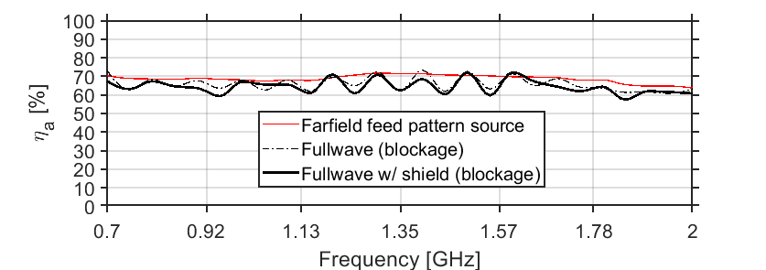

Figure 3. *Top-Left:* Simulated and measured return loss (*s*11 and *s*22) and coupling between the output ports for the two polarizations. *Top-Right*: System noise temperature at 8°C for four zenith pointing angles with the zenith direction broken down in component contributions. *Bottom*: Simulated aperture efficiency, with a band average of 66 % including blockage.

The combined noise temperature, including the LNA described in the next section, and the feed with spillover and aperture efficiency show in Figure 2 are commensurate with the requirements in section 2.

## LNA

Shi and Weinreb [7] have demonstrated a design that covers the DSA-2000 band with excellent performance both in terms of noise temperature (11 K) and gain flatness (±1 dB). The LNAs are based on Diramics [8] pHEMTs (pseudomorphic high electron mobility transistors) that have proven to have exceptionally low noise, good reliability, and good repeatability. A key feature of the design is the very low loss input coupling and matching circuit. Dissipative losses there have a significant effect on the noise temperature, but the use of a silver-plated connector and a suspended substrate microstrip minimize those losses. Additionally, it is important to avoid nickel-bearing gold plating on the microstrip line to minimize ohmic loss.

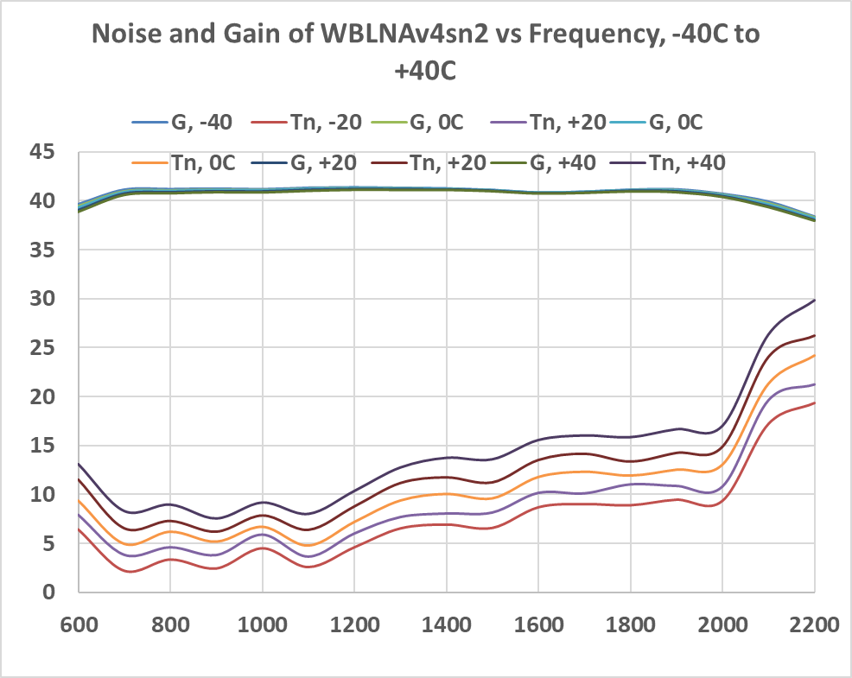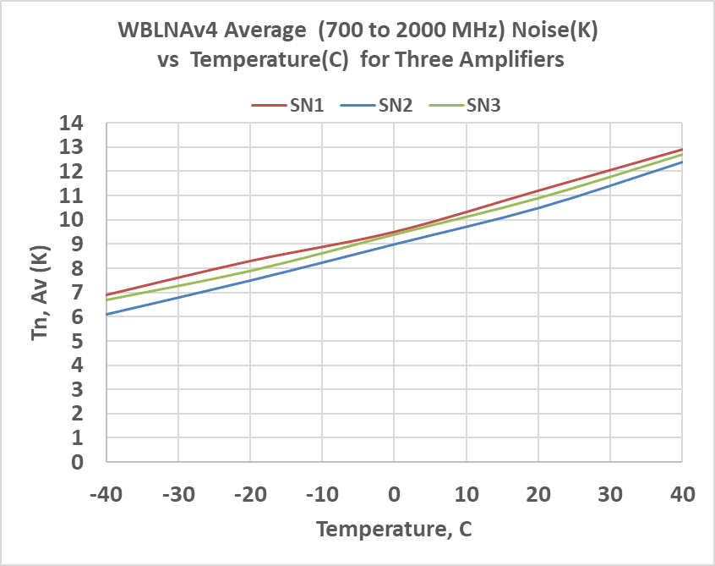

Noise temperature, K  
Gain, dB

Figure 4. *Left:* Noise and gain curves for a prototype LNA show excellent gain flatness and noise temperature across the observing band. *Right:* Three prototype amplifiers show the same dependence of noise on temperature.

Linearity measurements on prototype models show a 1-dB compression point of about −35 dBm. While this is well above the nominal system noise power level, the levels of RFI at the proposed sites currently and in the future are not well known so the possibility of intermodulation products still needs to be considered.

The LNAs will be attached directly to the feeds, exposed to solar heating, ambient temperatures, and moisture. Although the LNA gain is very stable over temperature, the noise temperature degrades with increasing temperature [7]. We are investigating cooling paints [9] that can significantly lower the amplifier temperature, even to below ambient. Moisture ingress is minimized by an O-ring between the halves of the amplifier block, as well as by connectors selected for hermetic sealing.

Current LNA modules incorporate a diode that can inject noise at the input to the LNA [7]. It is unlikely that this will be useful for amplitude calibration since the full DSA-2000 will have unprecedented capability for astronomical calibration. It is potentially a useful tool for diagnosis, but the decision to include or delete if from the final implementation will be made before production.

Losses in the cables at the output of the LNA are not critical due to the high (~ 40 dB) gain of the amplifier. Primary factors in the choice of cable will be physical ruggedness, qualification for outdoor use, and flexibility for the elevation wrap. A common failure mode is the attachment between the connectors and cable. Electrical and mechanical testing will be done on sample cables before production purchasing, and as necessary acceptance testing will be performed before installation in the field.

## Post-LNA electronics

The electronics between the LNAs and the digitizers comprise several units that must be considered as a whole to optimize properly. A critical aspect is the RFoF link, which has not yet been qualified to meet the DSA-2000 project requirements. A section is devoted to analysis of the link to justify the expectation that it will be able to meet the requirements for DS-2000.

The two physical modules are the FEM at the antenna, and the BEM in the control building. Prototype modules are shown in Figure 5. These are intended to evaluate and verify the RF performance, and the final design will be done in conjunction with the packaging design for manufacturability and operations considerations.

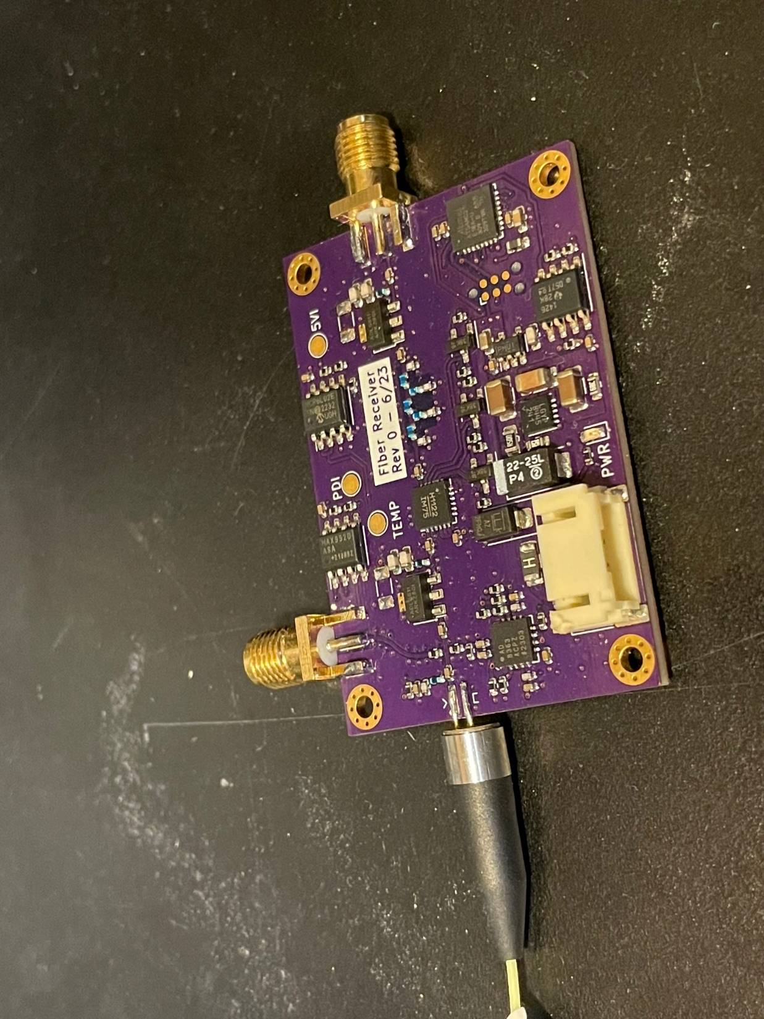

Figure 5. *Left:* A version of the prototype for the front-end module. The RF path is in the top block, with the laser diode and its fiber pigtail on the right. The lower block contains components for regulating power and monitor and control. *Right:* An iteration of the back-end module. The photodiode is on the left edge and the RF output on the right.

### Front-end module

The front-end module conditions the signal for transmission to the control building on the RFoF. The transmission side of the optical link is an integral part of the module. It is based on a laser diode that is directly modulated through its bias current. Laser diodes have high equivalent noise temperatures due to their relative intensity noise ($RIN$) so sufficient gain is required to overcome this contribution to the noise budget. However, the higher power levels make the signal path more susceptible to RFI harmonics and intermodulation products due to a non-linear transfer function.

Significant RFI is expected but the quantitative levels will depend on the final site choice and will vary and evolve with time so a best effort at mitigation is required. Minimization of out-of-band power with a band-pass filter is the first step. For RFI within the nominal band, low-level narrow-band signals can be rejected by dropping spectral channels in the radio camera. Higher levels will cause harmonics and intermodulation products, contaminating more channels. Up to 35% of the band can be cut and still allow the science goals to be achieved.

An ultimate limit on non-linearity is set by the range of the ADC, but the linearity of the analog path must also be considered. The laser diode in the optical link is likely the primary source of non-linearity, and the variation on performance among manufacturers and models is very large. D’Addario [10] has tabulated an extensive set of measurements comparing noise and linearity for a range of devices showing that even consecutive serial numbers can have a range of performance. The final choice of device is still open, but the circuit design is proceeding with the goal of supporting a variety of potential devices.

The design is being optimized in several aspects for the expected operating conditions. For example, the passband can be designed with a positive slope to de-emphasize RFI cell tower signals in the 600–850 MHz band where the laser noise lower. This will then be compensated in the BEM to provide a flat spectrum to the digitizer. Additionally, to allow adaptation to short- and long-term variations in RFI levels, selectable filters are included, and step attenuators enable optimization of levels for different filter selections and RFI levels.

Though not in the baseline plan, a very flexible varactor-tuned filter provides a −40-dB, 10-MHz-wide notch (appropriate for cell phone RFI), remotely tunable from 700 to 950 MHz, has been designed and tested. This same filter can be remotely tuned to give four −10-dB or two −20-dB notches at separate frequencies. This sharp filter allows the radio astronomy data within +40 and −20 MHz of the notch frequency to be processed.

### Optical link

The analog optical link, based on developments for the OVRO-LWA (long wavelength array) [11] and later the DSA-110, is divided between the FEM and the BEM but has to be analyzed as a whole, including the optical fibers. Loss at RF increase as the square of the optical loss, so the transmission quality is crucial. The most commonly used wavelengths are 1310 nm and 1510 nm. The baseline plan for the optical fiber network, based on cost performance tradeoffs, is to use Corning ALTOS® Loose Tube, Gel-Free Cable, performance option 01, which specifies a loss of 0.4 dB·km−1 at 1310 nm, and 0.3 dB·km−1 at 1550 nm. Other performance options have loss at 1550 nm as low as 0.2 dB·km−1 but for reasons discussed below, the 1310 band is preferred.

Dispersion in the fiber reaches zero at a wavelength in the range 1302–1322 nm, with a slope 0.092 ps·nm−2·km−1. Around a wavelength of 1550 nm the dispersion is ~ 17 ps·nm−1·km−1. For a laser diode linewidth of 1 nm, and a fiber length of 25 km the dispersion across the line is a significant 0.43 nm. The full implications of dispersion are analyzed in the Appendix.

On balance, an operating wavelength of 1310 nm appears to be the better choice and is adopted for the baseline plan. For 20 km of fiber, the corresponding optical loss is 8 dB, resulting in a loss of 16 dB at RF. An additional 1–2 dB optical loss may result from connections, splices, bends, and twists, leading to a maximum optical attenuation of 10 dB (20 dB for RF). For the dispersion we assume the above-mentioned fiber specifications, and a laser center wavelength specification of 1300–1320 nm, which puts the dispersion in the range −40 to 32 ps·nm−1. This results in a maximum phase difference between the first order modulation sidebands of a 2 GHz signal of 0.1°. For a 1 nm linewidth the variation in phase is ±1.4°, which increases the effective loss by a fraction of a decibel.

Diode selection is unfortunately complicated by the huge range of structures, materials, manufacturers, and packaging types. Cost is a critical determining factor, limiting the choice to a few Chinese manufacturers. Other factors to be considered in the selection in addition to wavelength and linewidth are quantum efficiency, relative intensity noise ($RIN$), and linearity.

Potential devices have been identified and tested by D’Addario [10] and a down-selection made for prototyping. For the design calculations we use the datasheet for a Shengshi 1310-nm DFB laser diode [12], though further testing may indicate a different part.

DSA-2000 antenna electronics will be in an uncontrolled temperature and humidity environment, and laser diodes are known to be very temperature dependent, so testing in an environmental chamber is required. Testing over 200 diodes for the OVRO-LWA [13] showed a lot of scatter in properties, differences from manufacturer’s test data (better and worse), and complicated temperature dependence. Temperature effects are partly due to the fundamental diode physics, but thermal effects in the packaging also produce significant and unpredictable changes. To deal with this, we will do extensive testing of samples to ensure that the variance in performance is acceptable, and possibly address quality control issues with the manufacturer. Temperature control of the laser diode is not ruled out but for reasons of reliability, power consumption, and complexity it will be used only if it is demonstrated that it is absolutely necessary.

Photodiodes present much less of a problem since they are readily available with high quantum efficiencies (70–90%). A dc voltage of a few volts needs to be applied to reduce the depletion layer capacitance for good frequency response. Silicon diodes are suitable for 1310 nm operation, but InGaAs is required for 1550 nm operation. Both have low dark current (fractions of a nA), so the shot noise contribution is small compared to the photon noise, even accounting for doubling for every 10°C rise in temperature. Optical power levels are low, so do not impose any significant constraints on the photodiode power handling. A Shengshi Optical Tech. Co., Ltd MPD-XXXXX diode [14] is assumed in the following discussion.

#### Link gain

It is useful to analyze optical links with directly driven laser diodes in terms of their current gain since they have low input impedance and high output impedance. Standard network theory is used to incorporate this in a 50-Ω RF circuit. The current gain of the optical link is the product of the laser diode quantum efficiency, $η_{ld}$, the optical gain, $g{}_{opt}$, and the photodiode quantum efficiency, $η_{pd}$. Typical values are 15–30% for $η_{ld}$, 5–90% for $g{}_{opt}$, and 70–90% for $η_{pd}$, leading to a range of current gains from −45 dB to −12 dB. There is no direct link between the gain and the optical power, but higher optical powers allow larger signal amplitudes. For the components mentioned above, the range of possible current gains is given in Table 1. The potential range is large (−50 dB to −20 dB), indicating that a narrower range of specifications needs to be discussed with the manufacturers. With the large number of devices required for DSA-2000, the likelihood of having close to a worst-case combination is high, and selecting specific combinations is unworkable.

Table 1. Gain parameters for the example laser diode and photodiode.

|  |  |  |  |
| --- | --- | --- | --- |
| parameter | best case | worst case | unit |
| laser efficiency | 21 | 5a | % |
| optical gain | −2.4b | −12c | dB |
| detector efficiency | 84 | 74d | % |
| total current gain | −20 | −52 | dB |
| Notes  a Not specified; estimated from maximum optical power at operating voltage.  b Fiber length = 2 km, 2 dB other loss  c Fiber length = 25 km, 2 dB other loss  d Not specified; based on difference between typical and max. | | | |

#### Linearity

In practice, the linearity of the laser modulation is not perfect, and deviations can cause intermodulation products. There does not appear to be an obvious theory for predicting non-linear terms in the gain, so it is necessary to use the datasheets if they provide those data, or to make measurements. The optical power vs. bias current can be expanded in polynomial form and the non-linear terms determined. In practice, a direct intermodulation measurement is a more accurate and reliable method.

Intermodulation products rise at a linear or higher order power relative to the signal, so it is important to keep the signal as low as possible without compromising the SNR. The amount of intermodulation also depends on the diode dc current bias and is temperature dependent [13]. It is very important to quantify the distortion of the RFoF link over the full range of device parameters and temperatures.

#### Link noise

Noise in the optical link is due primarily to the relative intensity noise of the optical power, defined by

|  |  |
| --- | --- |
| $$RIN=\frac{〈ΔP{\left(t\right)}^{2}〉}{P{}_{0}^{2}},$$ | (5) |

where $〈ΔP{\left(t\right)}^{2}〉$ is the mean square power fluctuation about the mean optical power, $P_{0}$.

When a laser diode is turned on by increasing the bias current, $I_{b}$, above the threshold current, $I_{th}$, the $RIN$ is initially very high, and then with increasing current the $RIN$ falls to some approximately asymptotic value. If an RF modulating current is added to the bias current its instantaneous amplitude must be low enough to keep the net current above the threshold current by a small amount. Consequently, both the permissible fractional modulation depth and the $RIN$ are weakly dependent on the dc bias point, and the achievable signal-to-noise is therefore also weakly bias dependent. An optimum bias setting for intermodulation can therefore be found with little impact on sensitivity.

As for the gain calculation, it is convenient to work in terms of current. The $RIN$ equivalent noise current $i_{n}$, in a bandwidth $B$ for a bias current $I_{b}$ has an rms value

|  |  |
| --- | --- |
| $$〈i_{n}^{2}〉=RIN{×\left(I_{b}-I_{th}\right)}^{2} for I_{b}>I{}_{th}$$ | (6) |

To keep the $RIN$ equivalent noise temperature below 1% of the system temperature, the gain before the laser needs to be sufficient for the system noise power rms current to exceed this by a factor of at least ten. For a total $RIN$ of −155 dB·Hz−1 and, the equivalent rms RF noise current driving the laser in a bandwidth $B=1.3 GHz$ would be ~ 13 μA, so the rms current due to the system noise would need to be ~ 90 μA, or a peak-to-peak of ~ 0.45 mA.

$RIN$ comprises laser noise and shot noise. The laser noise is often divided into an intrinsic mechanism due to beating of spontaneous emission with the stimulated radiation, and extrinsic mechanisms termed technical noise that results from disturbances external to the diode [15]. For our purposes, the details are not important, and the main distinction is that laser $RIN$ is independent of optical attenuation but the shot noise increases in proportion to optical attenuation. For high optical attenuation, the shot noise will eventually dominate over the laser noise. For 4 mW optical power, the shot noise contribution to $RIN$ is −161 dB·Hz−1, so that the laser $RIN$ component is −156 dBm·Hz−1. If there is 15 dB of optical loss, the shot noise $RIN$ is −153 dB·Hz−1, and the total is −146 dBm·Hz−1.

Post detection noise is primarily due to the amplifier following the photodiode. The baseline plan uses an Analog Devices ADL5611, which has a noise figure of ~ 2.1 dB in the relevant band. We will somewhat arbitrarily use an effective noise temperature of 300 K to account for the amplifier being operated with a source impedance different from the specification. At the photodiode the equivalent rms noise current over the band is then 0.33 μA. This is divided by the current gain to get the equivalent noise at the input. For example, a gain of −15 dB, raises the noise current to 10 μA.

Table 2 shows the range of possible noise levels for the best and worst cases. As for the gain calculations, we note that the large quantity makes it likely that worst cases will be encountered.

Table 2. Noise parameters for the example components.

|  |  |  |  |
| --- | --- | --- | --- |
| Parameter | best case | worst case | unit |
| total | −155 a | −150 | dB·Hz−1 |
| laser *RIN*b | −168 | −150 | dB·Hz−1 |
| shot noise (at laser output) | −161 | −155 | dB·Hz−1 |
| Equivalent noise current at laser diode *input* | | | |
| post-amplifier noise | 3.2 | 130 | μA |
| laser noise | 3.0 | 22 | μA |
| shot noise | 27.1 | 19 | μA |
| total noise | 27.4 | 133 | μA |
| a Actually ‘Typical’ in data sheet  b Total *RIN* minus shot noise *R­IN* | | | |

#### Dealing with tolerances

From the preceding discussion it is clear that, based on available information, there is a large range of parameter specifications to consider. Some of these are inevitable, such as variations in fiber lengths, but it is important to reduce variability. Trying to match laser transmitters and receivers is not feasible operationally since modules must be interchangeable. The first step is to have better quantitative analysis. Given the number of components, a statistical analysis needs to be conducted. Some of the parameters in the tolerance budget are correlated or anti-correlated, which needs to be accounted for. Finally, discussions with manufacturers will be required to guarantee some tighter specifications, as necessary. In some of the datasheets available, there are no lower limits given.

#### Laser safety

Laser safety, currently covered by the ANSI Z136.1-2022 standard, needs to be considered. The Class I (safe) limit for 1310 nm is 25 mW, and for 1550 nm it is 9.6 mW. It is unlikely that these will be exceeded, but necessary precautions will be taken if they are.

### Back-end module

The photodiode converts the optical signal to RF by the photodiode and then amplifiers and a digital step attenuator ensure that the signal to the radio camera digitizer is at the optimum level. The attenuator accounts for differences in levels due to the optical link performance and is an additional control for optimizing levels in the event of high RFI. An anti-aliasing filter for the digitizer is implemented with discrete components, and an appropriate drive circuit for the digitizer is provided.

# Monitor and control

Monitor and control will be developed in collaboration with the Monitor and Control subsystem team. For the antenna electronics, the monitor and control points will be on the same communications link as the antenna. The total number of monitor points will likely be similar to or less than for the DSA-110, which has 37 per antenna. Even for 2000 antennas this is a very small number to handle.

# Future work

Most of the building blocks for the analog signal path have been demonstrated to a good level of confidence, but further work is required, firstly for verification that the science requirements can be met, and secondly for production readiness.

The antenna feed and LNA are well progressed, so only minor changes for performance, if any, are anticipated. Tests of the LNA intermodulation will be done, though there is a low risk that it will be a problem. While the baseline plan is not to cool the LNA or its input pHEMT, or to integrate it with the feed, those are potential development paths that may be independently conducted.

Work is continuing on the FEM-RFoF-BEM part of the system to demonstrate that the design meets the science requirements, initially at room temperature and then over the anticipated temperature range. The design and components will be modified accordingly.

Once all the component parts are available, an extensive integration lab test will be done to ensure full system performance requirements are met. Further testing will be carried out on the five-antenna test array at OVRO, which will start to expose the system to conditions similar to the potential Nevada sites.

Production readiness will take the analog signal path elements through to a state where they can be mass produced. This will include:

* Final component evaluation for reliability;
* Highly accelerated lifetime testing;
* Packaging design for manufacturability, robustness, EMC, and installation;
* Monitor and control interfacing;
* Test documentation;
* Interface control documents;
* Mechanical drawing document control;
* Electrical schematic and PCD document control;
* Manuals;
* Test fixtures;
* Test protocols.

# Interfaces

The ASP has direct interfaces with the antenna station (AST), monitor and control (MNC), signal network (SNW) and the radio camera front-end (RCF). Detailed interface control documents will be developed in collaboration with those subsystem teams.

# Conclusions

The overall analog signal path is in good shape but not fully developed to the DSA-2000 requirements. The most progress is needed for the optical fiber link, particularly in demonstrating performance over the longest fiber runs. Calculations give high confidence that this is feasible, and the main challenge is ensuring that the specifications can be met without excessive need for screening and adjustment of individual circuits.

# References

[1] A. R. Thompson, J. M. Moran, and G. W. Swenson Jr., *Interferometry and Synthesis in Radio Astronomy*. Malabar: Krieger, 1998.

[2] J. Flygare and D. P. Woody, “Wideband feed and reflector ground shield for the Deep Synoptic Array (DSA-2000),” in *2023 IEEE International Symposium on Antennas and Propagation and USNC-URSI Radio Science Meeting (USNC-URSI)*, Jul. 2023, pp. 761–762. doi: 10.1109/USNC-URSI52151.2023.10237516.

[3] J. Flygare, “DSA-2000 Feed Requirements,” Caltech, D2k-00043, Oct. 2023.

[4] J. Flygare, “DSA-2000 Feed Design,” Caltech, D2k-00044, Oct. 2023.

[5] T. L. Landecker, M. D. Anderson, D. Routledge, R. J. Smegal, P. Trikha, and J. F. Vaneldik, “Ground radiation scattered from feed support struts: A significant source of noise in paraboloidal antennas,” *Radio Science*, vol. 26, no. 2, pp. 363–373, 1991.

[6] A. C. Ludwig, “Definition of cross polarization,” *IEEE Trans. Antennas Propag.*, vol. AP21, no. 1, pp. 116–119, 1973, doi: 10.1109/tap.1973.1140406.

[7] J. Shi and S. Weinreb, “Room-temperature low-noise amplifier with 11-K average noise from 0.6 to 2 GHz,” *IEEE Microwave and Wireless Technology Letters*, pp. 1–4, 2023, doi: 10.1109/LMWT.2023.3315269.

[8] Diramics AG, Hinterbergstrasse 28, 6312 Steinhausen Switzerland, , [Online]. Available: https://diramics.com/

[9] X. Li, J. Peoples, P. Yao, and X. Ruan, “Ultrawhite BaSO4 paints and films for remarkable daytime subambient radiative cooling,” *ACS Applied Materials & Interfaces*, vol. 13, no. 18, pp. 21733–21739, May 2021, doi: 10.1021/acsami.1c02368.

[10] L. D’Addario, “Evaluation of laser diodes for possible use in DSA-2000 RF-over-fiber signal transmission,” Internal Memo, Sep. 2022.

[11] S. Weinreb and K. Hu, “Components for OVRO LWA fiber-optic link,” Caltech internal, Jul. 2014.

[12] “1310nm DFB Pigtailed Components Datasheet, Version Mar. 2016,” Shengshi Optical Tech. Co., Ltd, Address: 5-floor,Block B Creative Building, Shaojia Tsui, Wenzhi St., Hongshan District, Wuhan, City, Hubei, P.R.China, Datasheet.

[13] J. W. Lamb, “LWA-352 laser driver design,” Memo, in prep.

[14] “1100nm-1650nm Detector Pigtailed Components Datasheet,” Shengshi Optical Tech. Co., Ltd, Address: 5-floor,Block B Creative Building, Shaojia Tsui, Wenzhi St., Hongshan District, Wuhan, City, Hubei, P.R.China, Datasheet, Mar. 2016.

[15] “Relative Intensity Noise of Distributed Feedback Lasers, Rev. 1.5,” eagleyard Photonics GmbH, Application Note. Accessed: Oct. 19, 2023. [Online]. Available: https://www.laserdiodesource.com/com.laserdiodesource/technotes/EAGLEYARD-PHOTONICS-Relative-Intensity-Noise-of-Distributed-Feedback-Lasers.pdf

[16] “12 Orders of Coherence Control,” TOPTICA Photonics AG, Application Note. Accessed: Oct. 21, 2023. [Online]. Available: https://www.toptica.com/fileadmin/Editors_English/12_literature/01_quantum_technologies/toptica_12_orders_of_coherence_control.pdf#:~:text=In%20mathematical%20terms%2C%20linewidth%20and%20coherence%20length%20are,depending%20on%20the%20spectral%20profile%20of%20the%20laser.

# Appendix

For long fibers we need to consider the effect of dispersion from several aspects, such as the phase difference between modulation sidebands, the decoherence due to laser linewidth, and delay changes due to frequency drift. The basis of the calculation is the dispersion equation for SM-28 fiber from the Corning datasheet for an operating wavelength $1200 nm≤λ≤1600 nm$

|  |  |
| --- | --- |
| $$D\left(λ\right)=\frac{S_{0}}{4}\left[λ-\frac{λ_{0}^{4}}{λ^{3}}\right],$$ | (7) |

where the zero-dispersion wavelength, $λ_{0}$ is

|  |  |
| --- | --- |
| $$1302 nm≤λ_{0}≤1322 nm,$$ | (8) |

and the zero-dispersion slope is

|  |  |
| --- | --- |
| $$S_{0}≤0.092 ps∙{nm}^{-2}∙{km}^{-1}.$$ | (9) |

Quantitatively, we find $\left|D\right| ≲0.4 ps∙{nm}^{-1}∙km^{-1}$ for the range of laser and fiber around a nominal 1310 nm, and $D≈17.5 ps∙{nm}^{-1}∙km^{-1}$ for the 1550 band.

## Sideband phase decoherence

If the optical signal is modulated at an RF frequency of $f_{RF}$, the first order sidebands will have a wavelength difference of $Δλ,$

|  |  |
| --- | --- |
| $$Δλ=\frac{2cf_{RF}}{ν_{c}\left(ν{}_{c}+f_{RF}\right)}.$$ | (10) |

where $ν_{c}$ is the laser carrier frequency, and $c$ is the vacuum speed of light. Using (7), the relative delay can be calculated for a 25 km long fiber, giving a maximum phase difference between $f_{RF}=$ 2 GHz sidebands of < 1° at 1310 nm, and < 8° at 1550 nm. This causes negligible decoherence.

## Linewidth decoherence

The maximum specified linewidth for the laser diode discussed in this document is $Δλ=1 nm$ at the −20 dB points. The delay, $δt\left(δλ\right)$, at a wavelength $δλ$ away from the line center frequency can be calculated from (10), and the integral of the modulation signal amplitude over the width of the line will yield the average signal. For the weighting function, we have to assume a line shape, with a couple of choices being a Lorentzian and a Gaussian. Using the linewidth definition above, these weighting functions are

|  |  |
| --- | --- |
| $$p_{L}\left(δλ\right)=\frac{1}{1+{\left(\frac{δλ}{0.0503 Δλ}\right)}^{2}} , \\ p_{G}\left(δλ\right)=\exp{-{\left(\frac{δλ}{0.233 Δλ}\right)}^{2}} ,$$ | (11) |

respectively. The integral can be done with sufficient accuracy by taking limits of $±Δλ$. Hence the effective signal amplitude is given by

|  |  |
| --- | --- |
| $$a= \frac{\int_{-Δλ}^{Δλ}{p_{X}\left(δλ\right)}\exp{2πif_{RF}δt\left(δλ\right) dδλ}}{\int_{-Δλ}^{Δλ}{p_{X}\left(δλ\right) dδλ}} .$$ | (12) |

Results of this calculation are shown for a 25-km fiber in Figure 6. For the 1310-nm band, the decoherence is negligible, even for the worst-case assumptions. For the 1550-nm band, the effect is very significant, and outweighs the lower loss of the fiber.



Figure 6. Coherence loss due to laser diode linewidth. For the 1330-nm band, the zero-dispersion frequency is chosen to be 1322 nm, which in combination with the minimum specified laser frequency, gives the maximum decoherence. ‘L” and ‘G’ refer to Lorentzian and Gaussian linewidths respectively.

An implicit assumption is that the jitter in the laser frequency is on time scales much shorter than the RF period otherwise the effect would be to add phase noise to the demodulated signal. In general, the coherence time is the inverse of the linewidth (e.g., .[16]), which is 125 GHz, justifying the assumption.

## Delay drift

If the laser wavelength changes by $Δλ$, the optical delay will change by

|  |  |
| --- | --- |
| $$Δτ=λ Δλ d D\left(λ\right) .$$ | (13) |

As an indication of the effect, we take some 1310-nm laser diode frequency vs temperature measurements [13] that yielded a drift of 0.08 nm·K−1. Combined with (13) we find a delay sensitivity for a 25-km fiber of ~ 1 ns· K−1 at 1310 nm, and ~ 1 ns· K−1 at 1550 nm. The sensitivity of the diodes selected for DSA-2000 will need to be evaluated in this light and measures taken to ensure that the rate of change of temperature is appropriately limited.

1. By convention, antennas and feeds are analyzed in transmission, and reciprocity is invoked to derive the receiving characteristics.